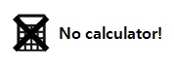
Fractional and Negative Indices Homework
Literacy  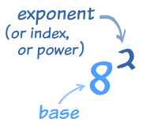 | Research  What is a logarithm?  How would you find the value of $\log_{10}100$ and $\log_{2}8$? | Memory  Learn these rules:  $a^{-b}=\frac{1}{a^{b}}$  Tip: The root is found in the denominator, like in a tree - the root is at the bottom.  $a^{\frac{c}{d}}=\sqrt[d]{a^{c}}$
Skills  Find the value of:  - ${25}^{\frac{1}{2}}$ - $6^{-2}$  - $9^{-1}$ - $8^{\frac{1}{3}}$  - $5^{-3}$ - ${49}^{-\frac{1}{2}}$  - ${32}^{\frac{2}{5}}$ - ${144}^{0.5}$  - ${\left(\frac{1}{8}\right)}^{-2}$ - ${\left(\frac{3}{4}\right)}^{-3}$ |  | Stretch  Put these numbers in  ascending order  $$8^{\frac{1}{2}} { 4}^{\frac{2}{3}} {32}^{\frac{1}{3}} { 2}^{\frac{5}{6}}$$

