**Literacy**

Describe the important facts about adding decimals.

**Research**

Where and when were decimals first used?

What did people do before decimals?

**Memory**

When dividing decimals you must make the divisor a whole number.

$$32.4 ÷0.03$$

Make this whole by multiplying by 10, 100, 1000

Do the same to this number

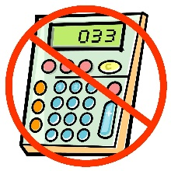

**Stretch**

Are these calculation correct? If not show where they are wrong.

3.28 x 5.5 = 18.04

180.4 ÷ 5.5 = 32.8

180.4 ÷ 328 = 0.55

0.328 x 0.55 = 0.1804

**Skills Practice (No Calculator)**

Calculate the following answers:

**Multiplying and Dividing**

2.4 x 3=

12.7 x 5 =

6.72 x 10 =

2.4 ÷ 3=

12.5 ÷ 5 =

68.5 ÷ 10 =

12.4 ÷ 1.2 =

**Adding and Subtracting**

2.4 + 3.3 =

12.7 + 2.8 =

6.72 - 5.49 =

245.987 - 16.204 =

34.69 + 72.507 =

45.53 – 16.69=