Factorising Quadratics Homework
Literacy  Factor  Quadratic  Sum  Product  Coefficient | Research  Write a mathematical  definition for every  keyword in the  literacy section. Make  sure they are  accurate and precise! | Memory  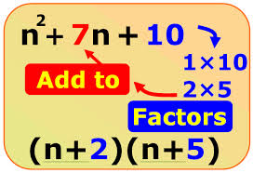
Skills  Factorise the following expressions.  1) x² + 6x + 8  2) x² + 2x – 15  3) x² – 6x + 8  4) x² – 8x + 15  5) x² – x – 6  6) x² + 3x - 108  Don’t forget presentation standards. The working out IS the maths!  All questions are to be checked by expanding back out when you’ve got the answer! |  | Stretch  7)  Factorise the following:  x² – 9  (Hint: This is the  same as x² + 0x – 9)  8)  2x² – 6x – 20  (Hint: Take out a common factor FIRST)

