**Memory**

How do you find the size of one item on a Pie Chart?

**Research**

Why does the UK government do a census every 10 years?

**Literacy**

Frequency Polygon

Pie Chart

Data

Grouped Data

**Stretch**

Why could using Pie Charts to compare two sets of data not be reliable?

What is wrong with the graph below?

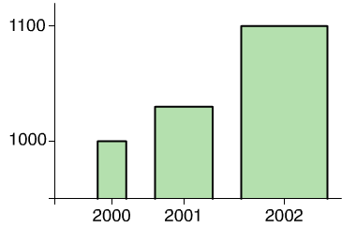

**Skills Practice**

Draw a frequency polygon and a pie chart of the following data

|  |  |
| --- | --- |
| Height of Students (h cm) | Frequency |
| 160 ≤ h < 165 | 10 |
| 165 ≤ h <170 | 14 |
| 170 ≤ h < 175 | 8 |
| 175 ≤ h < 180 | 5 |
| 180 ≤ h < 185 | 3 |