 |  |  | Comparative bar charts
Literacy  Key words: Write a sentence to explain each word.  - Frequency  - Bar Chart  - Comparative | Research  Find a piece of data in a newspaper, magazine or on the internet, which is displayed in a bar chart. Glue this into your book and write a sentence to explain what you think the bar chart shows. |  | Memory  All bars must be equal width and equally spaced.  Frequency on the y-axis must be evenly spaced.  Axes must be labelled and a key drawn.
Skills  Pupils at Mathsville School are given a choice of summer sports. The numbers chosen for each sport are given below:  Sport Cricket Athletics Swimming Rounders Tennis  Girls 5 9 4 7 5  Boys 13 8 5 2 2  Draw a comparative bar chart in your book to display this data.  Use the memory cues to check your work. |  | 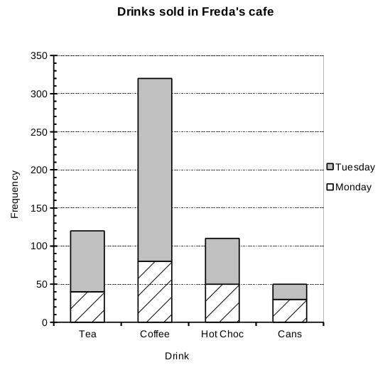  Stretch  - What is this survey about?  - What is the mode?  - How many people had hot chocolate?  - How many cans were sold on Monday and on Tuesday?  - How many drinks were sold altogether?
 |  |  | Comparative bar charts
Literacy  Key words: Write a sentence to explain each word.  - Frequency  - Bar Chart  - Comparative | Research  Find a piece of data in a newspaper, magazine or on the internet, which is displayed in a bar chart. Glue this into your book and write a sentence to explain what you think the bar chart shows. |  | Memory  All bars must be equal width and equally spaced.  Frequency on the y-axis must be evenly spaced.  Axes must be labelled and a key drawn.
Skills  Pupils at Mathsville School are given a choice of summer sports. The numbers chosen for each sport are given below:  Sport Cricket Athletics Swimming Rounders Tennis  Girls 5 9 4 7 5  Boys 13 8 5 2 2  Draw a comparative bar chart in your book to display this data.  Use the memory cues to check your work. |  | Stretch  - What is this survey about?  - What is the mode?  - How many people had hot chocolate?  - How many cans were sold on Monday and on Tuesday?  - How many drinks were sold altogether?

